ENCOMPASS

|  |  |
| --- | --- |
| Name | Student Number |
| JULIANNA VENTER | U20433752 |
| MORGAN BENTLEY | U18103007 |
| Keabetswe Mothapo | U21543462 |
| Ronin Brookes | U19069686 |
| Sameet Keshav | U21479373 |

Technical Installation Manual

1. **Introduction**

This installation **manual** provides step-by-step instructions for setting up a Yarn environment to run a specific application and API. Ensure you have the necessary prerequisites installed before proceeding. This guide assumes you have basic knowledge of working with Node.js and Yarn.

1. **The Steps**

* Clone the Repository:

- Open your preferred terminal or command prompt.

- Change your current working directory to the location where you want to clone the repository.

- Execute the following Yarn command to clone the repository:

The link: <https://github.com/COS301-SE-2023/Encompass>

* Setup a MongoDB:

- Install MongoDB on your system following the instructions for your operating system.

- Once installed, ensure the MongoDB service is running.

* Setu. env File:

- Navigate to the root directory of the cloned repository using the terminal.

- Create a new file named `.env` using any text editor (e.g., VSCode, Notepad, etc.).

- Add the necessary environment variables to this file. These variables might include database connection strings, API keys, and other configurations specific to your application. For example:

NX_ENVIRONMENT=development

NX_MONGO_DB_URL=mongodb://127.0.0.1:27017/encompass-database

AWS_BUCKET_NAME=example-images

AWS_BUCKET_REGION=eu-west-1

AWS_ACCESS_KEY_ID=example-key

AWS_SECRET_KEY=example-key

BASE_URL=http://localhost:3000

Note that you have to create your own amazon variable values for images to work on the application, where “example” is used above.

* Build the Application and API:

- Run the following Yarn command in the terminal to build the application:

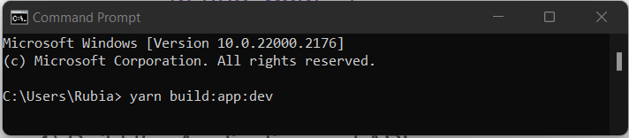

This will compile and bundle the front-end application for development.

* Next, execute the following Yarn command to build the API:

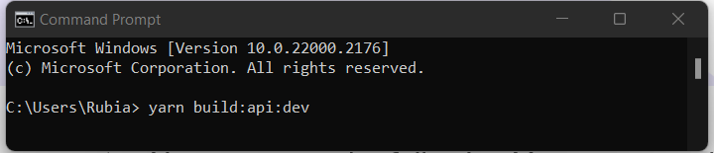

This will compile and bundle the API code for development.

* Start the Application and API:

- To run the application, use the following Yarn command:

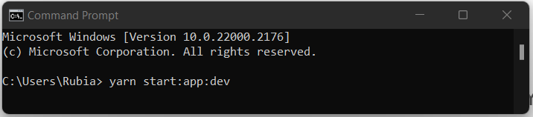

This will start the development server for the front-end application.

- To start the API, use the following Yarn command:

This will launch the development server for the API.

Ensure that you keep the terminal windows running for both the application and API servers to keep them operational.

1. **Closing**

Congratulations! You have successfully set up the Yarn environment and launched the application and API for development. You can now access the application by visiting the specified localhost address (localhost:4200) in your web browser.

If you encounter any issues, refer to the error messages in the terminal for debugging or consult the project's documentation for troubleshooting tips.

